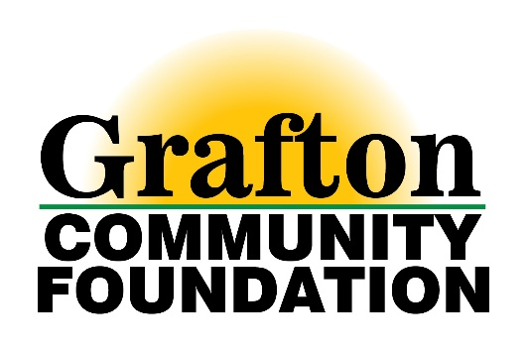

SuperGrant
Guidelines for Application

The Grafton Community Foundation has established a SuperGrant which will be awarded in late Spring of each year. The Advisory Committee plans to award one SuperGrant in an amount up to $50,000 each year. The exact amount will be determined each year.

Funding is designed to support a broad range of community needs, including arts and culture, social and health services, education, recreation, preservation and emergency services. Grant funds may be used to start a new project or program or enhance or maintain an existing program.

Eligible applicants must be 501(c)3 nonprofits or organizations that are exempt from filing for a 501(c)3 status, located in and providing services for citizens of Grafton, ND, St. Thomas, ND and the immediate surrounding area. This includes units of government and school corporations. To confirm eligibility, please contact Amy Stromsodt at amy@ndcf.net or 701-795-1531. Only one application will be accepted per qualified organization per year.

The Grafton Community Foundation DOES NOT accept requests for:

- Individuals
- Previously incurred debt
- Political campaigns
- Efforts to influence legislation of any governmental body
- General operating expenses

Application Process and Timeline

Interested applicants are asked to submit a Letter of Intent (LOI) by the prescribed deadline. The Advisory Committee will review all LOIs relative to applicability to funding parameters, alignment with funding criteria, quality and project merits. A select number of applicants will be chosen to submit a full proposal and may be asked to participate in a brief presentation/interview with the Advisory Committee.

Timeline

March 1 Letters of Intent Due
April 1 Advisory Committee to invite proposals from select applicants
May 1 Full Proposals Due
June 1 (On or around this date) Finalist interviews with Advisory Committee
June 15 (On or around this date) Public Announcement of grant recipient

Letters of Intent

All Letters of Intent must be submitted online. Visit www.ndcf.net/grafton to get started.

The following MUST be included in the LOI:

  - Mission statement and brief description of the organization
  - Number and type of persons served in the previous year
  - Project description
  - Initial timeline of the project
  - Total cost of the project
  - Documented unmet community need (new or existing)
  - Any matching funds (in-kind or cash) or challenge grants that will be used to leverage this grant
  - Impact on the Grafton/St.Thomas communities and how this will meet the Grafton Community Foundation’s mission to “Improve the Quality of Life for Citizens in the Grafton/St. Thomas Area”
  - How the organization collaborates and cooperates with other organizations in the community
  - Ability to sustain the project (if applicable) once the grant funds have been expended

Full Proposal

If you are invited to submit a full proposal, you will be asked to provide:

- Financial Statements, preferably audited, showing actual expenses, including balance sheet and income/expenses (or most recent I.R.S. Form 990)
- Commitment letters from additional funders
- Current organizational budget
- Detailed project budget
- List of Board members and their affiliations
- Brief description of key agency staff, including those involved in the proposed project

Grant Disbursement and Evaluation

Before grant funding is disbursed, the grantee and the Grafton Community Foundation will execute a grant agreement requiring a final grant evaluation within 1 year of receiving the fund, and intermediate reports, as requested, depending on the project.

